# **NEWS TRACKER APPLICATION** **TEAM ID:** PNT2022TMID49399

[**SETTING UP APPLICATION ENVIRONMENT**](https://careereducation.smartinternz.com/Student/guided_project_workspace/7918#collapse1) **CREATE IBM CLOUD ACCOUNT**

**Step 1:**

# Navigate to ibm.com/academic and register with your smartinternz mail

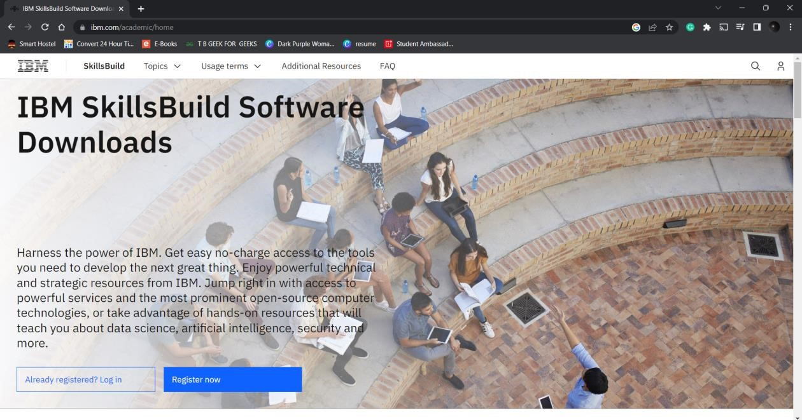

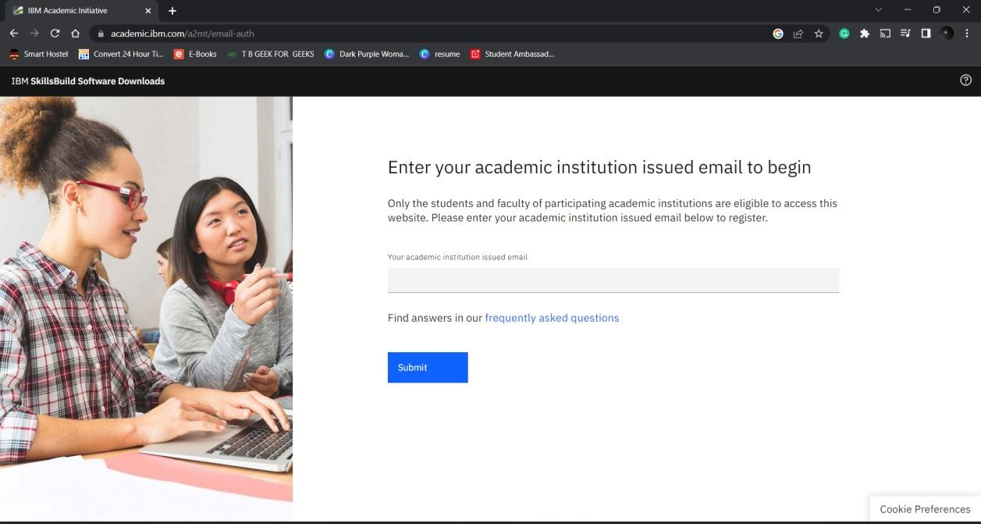

**NEWS TRACKER APPLICATION** **TEAM ID:** PNT2022TMID49399

# **Step 2**: Now go to cloud.ibm.com and login with your registered mail id along with coupon code obtained from ibm.com/academic

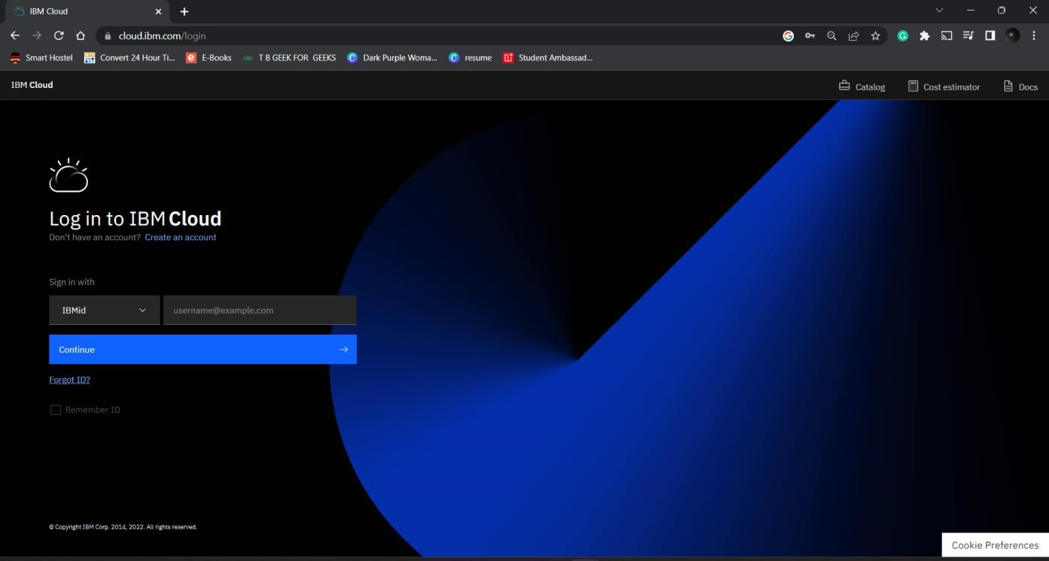

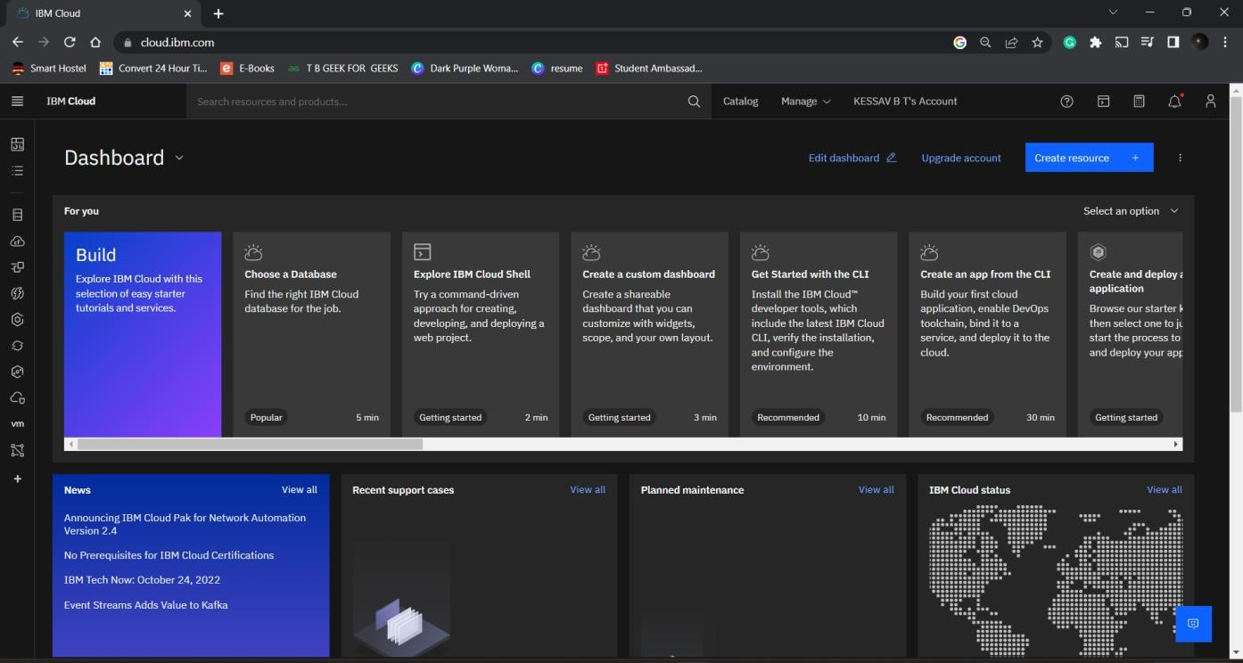

**OUTPUT**

Cloud account created successfully.